Using Python, draw a X-Y graph.

In [1]:

**import** matplotlib.pyplot **as** plt

In [5]:

*#Take the first array as input*

input_string1 **=** input("Enter elements of the first list separated by space ") list1 **=** input_string1**.**split()

*#Convert each item to int type*

**for** i **in** range(len(list1)): list1[i] **=** int(list1[i])

*#Take the second array as input*

input_string2 **=** input("Enter elements of the second list separated by space ") list2 **=** input_string2**.**split()

*#Convert each item to int type*

**for** i **in** range(len(list2)): list2[i] **=** int(list2[i])

*#Print the integer lists*

print("First list: ", list1) print("Second list: ", list2)

Enter elements of the first list separated by space 1 2 3 4 5

Enter elements of the second list separated by space 3 5 7 2 1

First list: [1, 2, 3, 4, 5]

Second list: [3, 5, 7, 2, 1]

In [3]:

*# Line graph*

plt**.**figure()

plt**.**plot(x, y, color**=**'blue', label**=**'Line Graph') plt**.**xlabel('X-axis')

plt**.**ylabel('Y-axis')

plt**.**title('Line Graph Example') plt**.**grid(**True**)

plt**.**legend() plt**.**show()

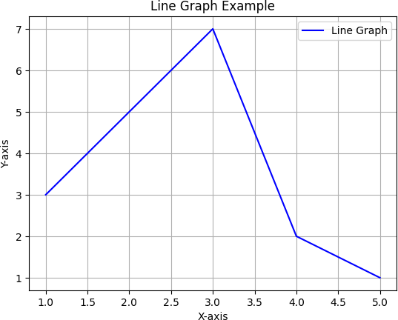

In [4]:

*# Bar graph*

plt**.**figure()

plt**.**bar(x, y, color**=**'yellow', label**=**'Bar Graph') plt**.**xlabel('X-axis')

plt**.**ylabel('Y-axis')

plt**.**title('Bar Graph Example') plt**.**grid(**True**)

plt**.**legend() plt**.**show()

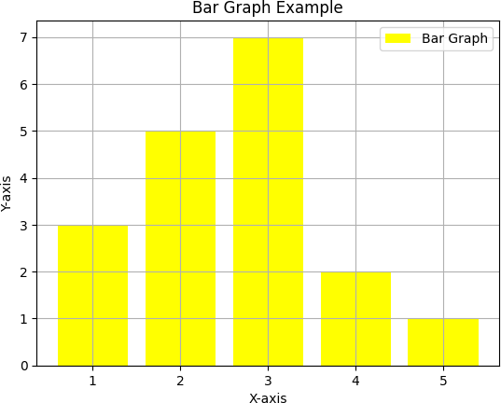

In [5]:

*# Histogram*

plt**.**figure()

plt**.**hist(y, bins**=**5, color**=**'green', edgecolor**=**'black', label**=**'Histogram') plt**.**xlabel('Y-axis')

plt**.**ylabel('Frequency')

plt**.**title('Histogram Example') plt**.**grid(**True**)

plt**.**legend() plt**.**show()

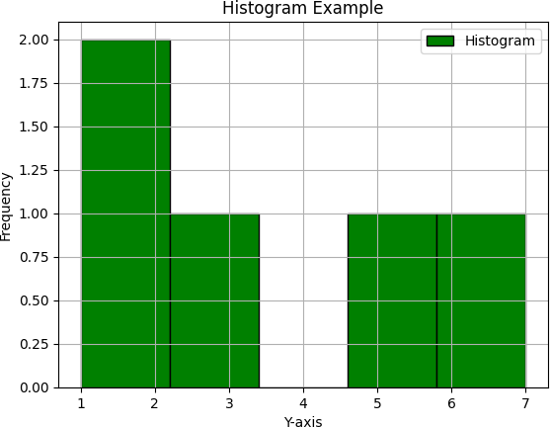

In [6]:

*# Scatter plot*

plt**.**figure()

plt**.**scatter(x, y, color**=**'red', label**=**'Scatter Plot') plt**.**xlabel('X-axis')

plt**.**ylabel('Y-axis')

plt**.**title('Scatter Plot Example') plt**.**grid(**True**)

plt**.**legend() plt**.**show()

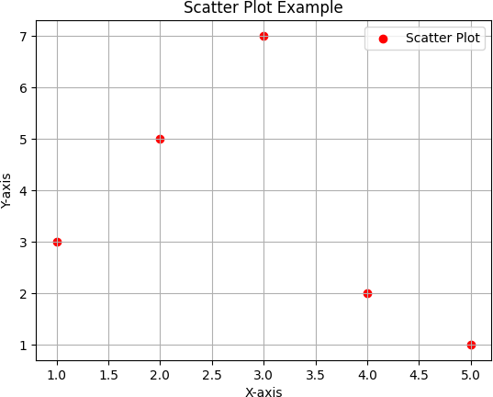

In [7]:

*# Pie chart*

plt**.**figure()

plt**.**pie(y, labels**=**x, autopct**=**'%1.1f%%', startangle**=**90, colors**=**['yellow', 'orange', 'red', 'green', 'blue']) plt**.**title('Pie Chart Example')

plt**.**axis('equal') plt**.**show()

